**INTEGRATION TESTING:**

Integration testing is the second level of the software testing process after unit testing. In this testing, units or individual components of the software are tested in a group. The focus of the integration testing level is to expose defects at the time of interaction between integrated components or units.

**Testing All Functionalities:**

**test_case-01-> user_create and user_login**

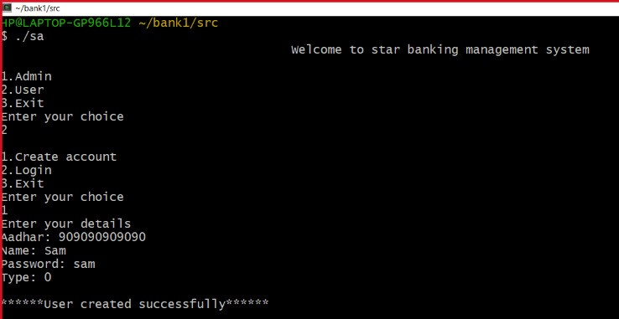

**Test_case-02->is_admin**

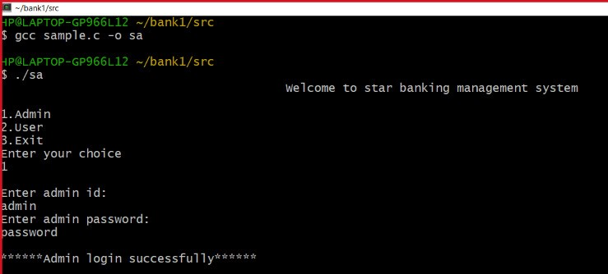

**test_case-03-> debit**

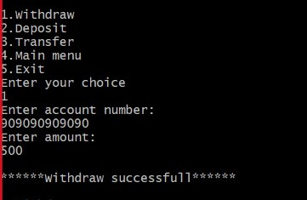

**test_case-04-> credit**

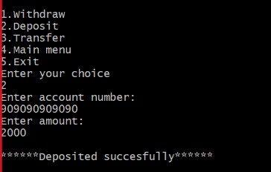

**test_case-05-> Transfer**

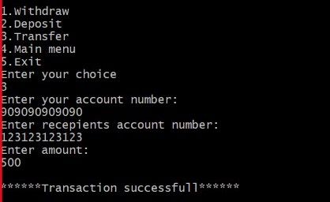

**test_case-06-> get_balance**

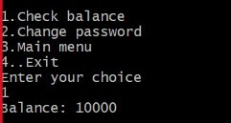

**test_case-07->change_password**

